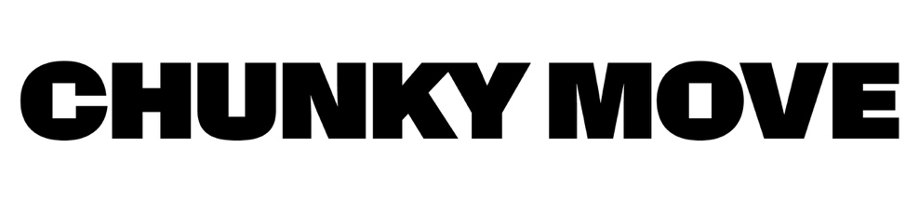

Accessing the Chunky Move building:

This is what our building looks like. We share this building with ACCA (Australian Centre for Contemporary Art).
It is a large rusty steel building and is one of Melbourne’s architectural icons.
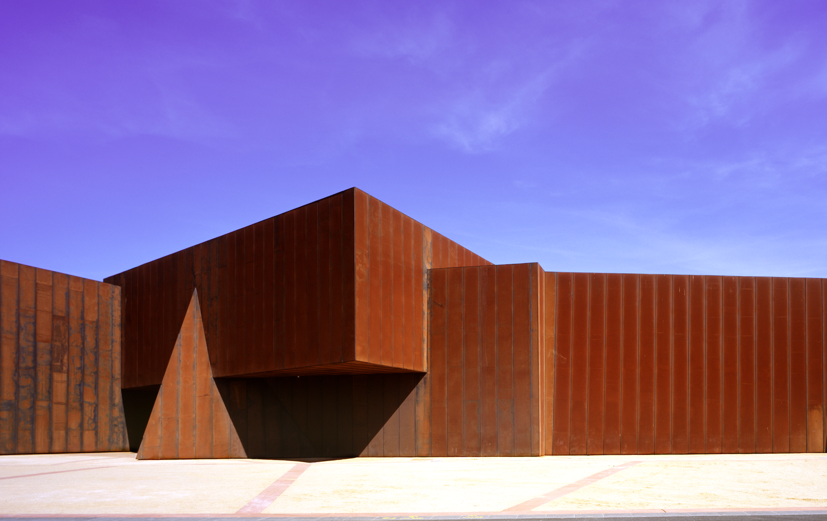

There are two ways to arrive at Chunky Move
- Grant Street: walk past the yellow sculpture. Walk through the tunnel into the courtyard. The front door is on the right at the end of the tunnel.
This is the yellow sculpture on Grant Street:
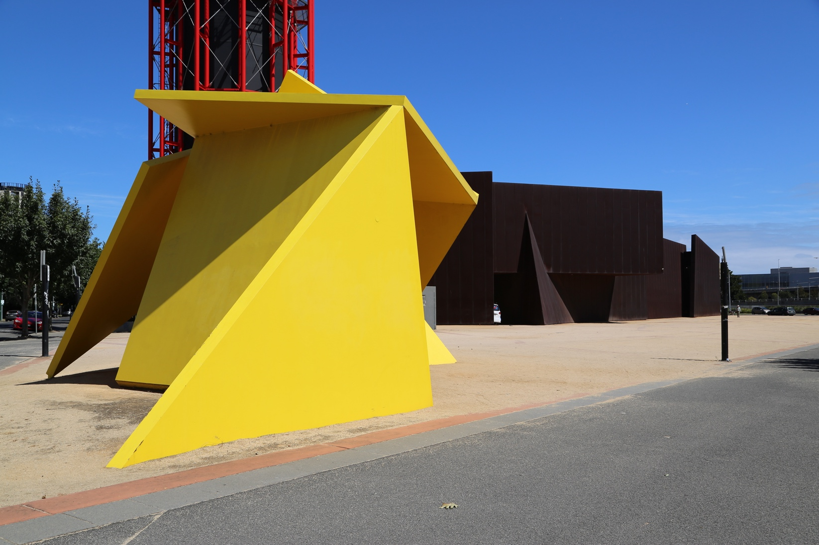
This is the tunnel to walk through:
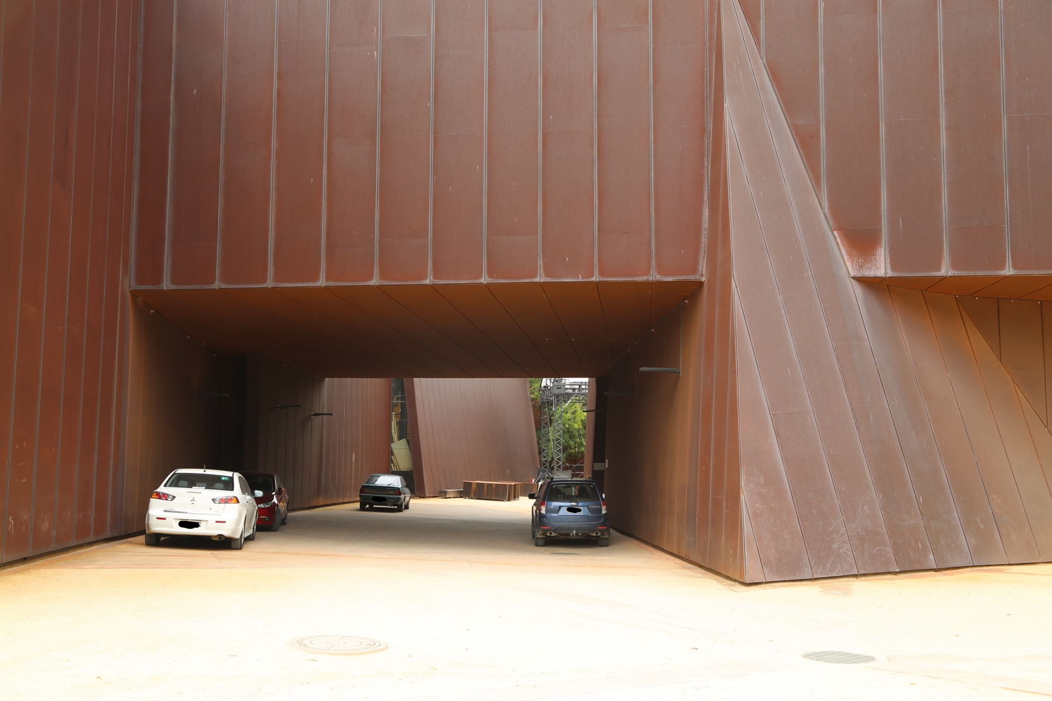

- Sturt Street: Walk up the path between ACCA and Malthouse Theatre into the courtyard. The Chunky Move sign is on the brown building on the right.
This is the ACCA building on Sturt Street:
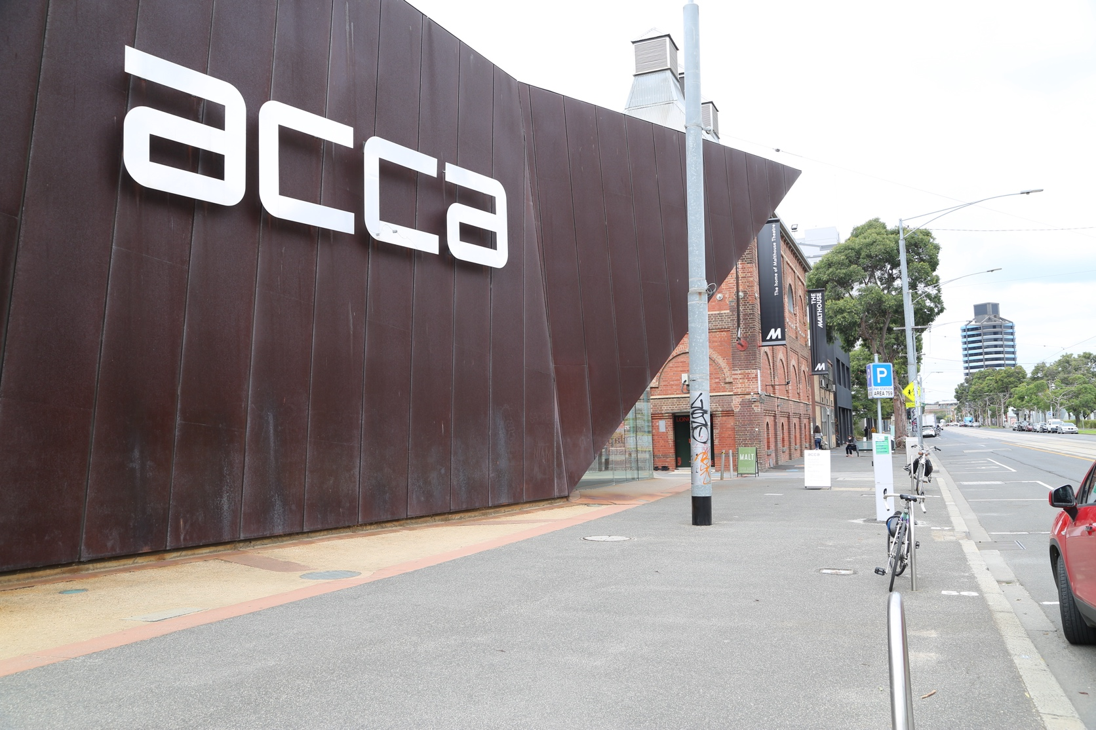

This is the entrance to Chunky Move.
The front door is in the large courtyard between Malthouse Theatre and ACCA. This entrance has no steps.
This is the front door:
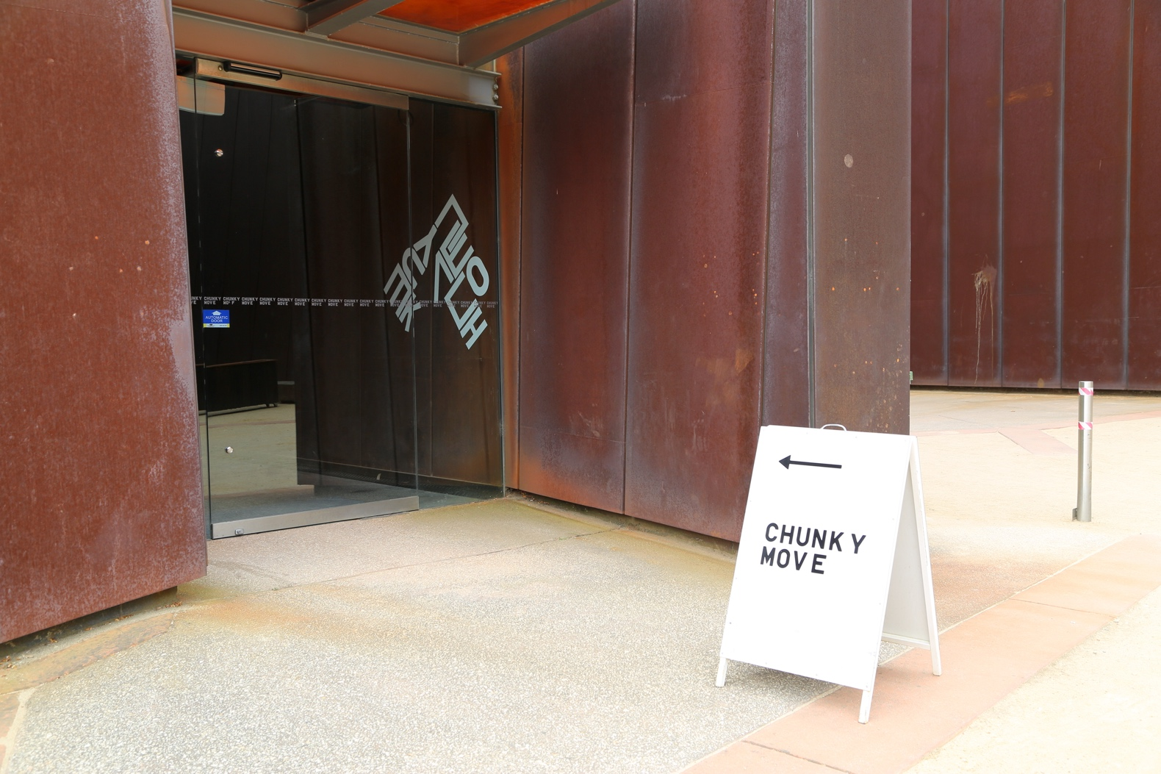
At our front door there is an intercom. Press the round silver button and a Chunky Move team member will let you in. The automated door will open towards you. You will need to stand back one metre from the door.
This is the button to open the automated door:
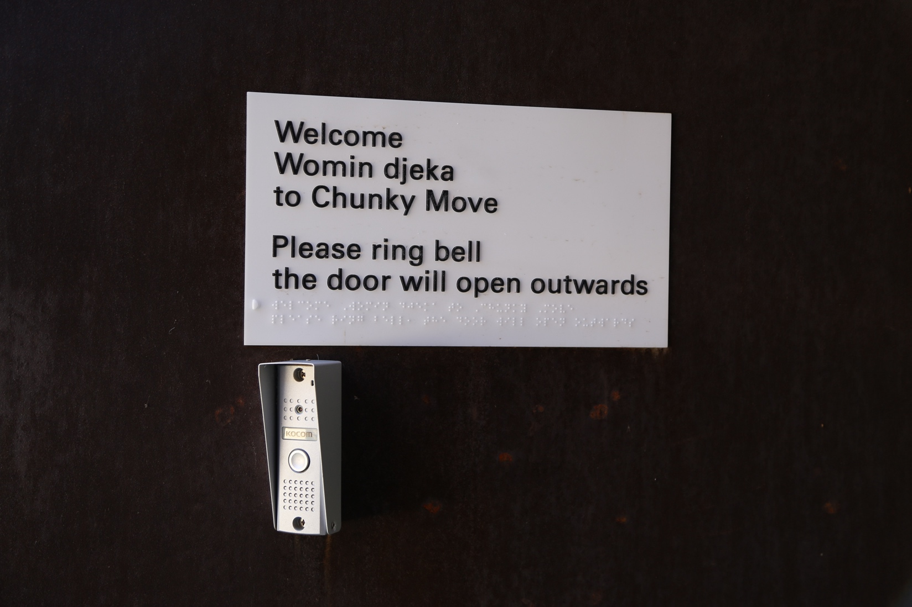
In the entrance there are stairs on the left and a lift on the right. The front desk is upstairs.
You will meet a Chunky Move team member if you walk up the stairs or take the lift to level 1.
This is the entrance:
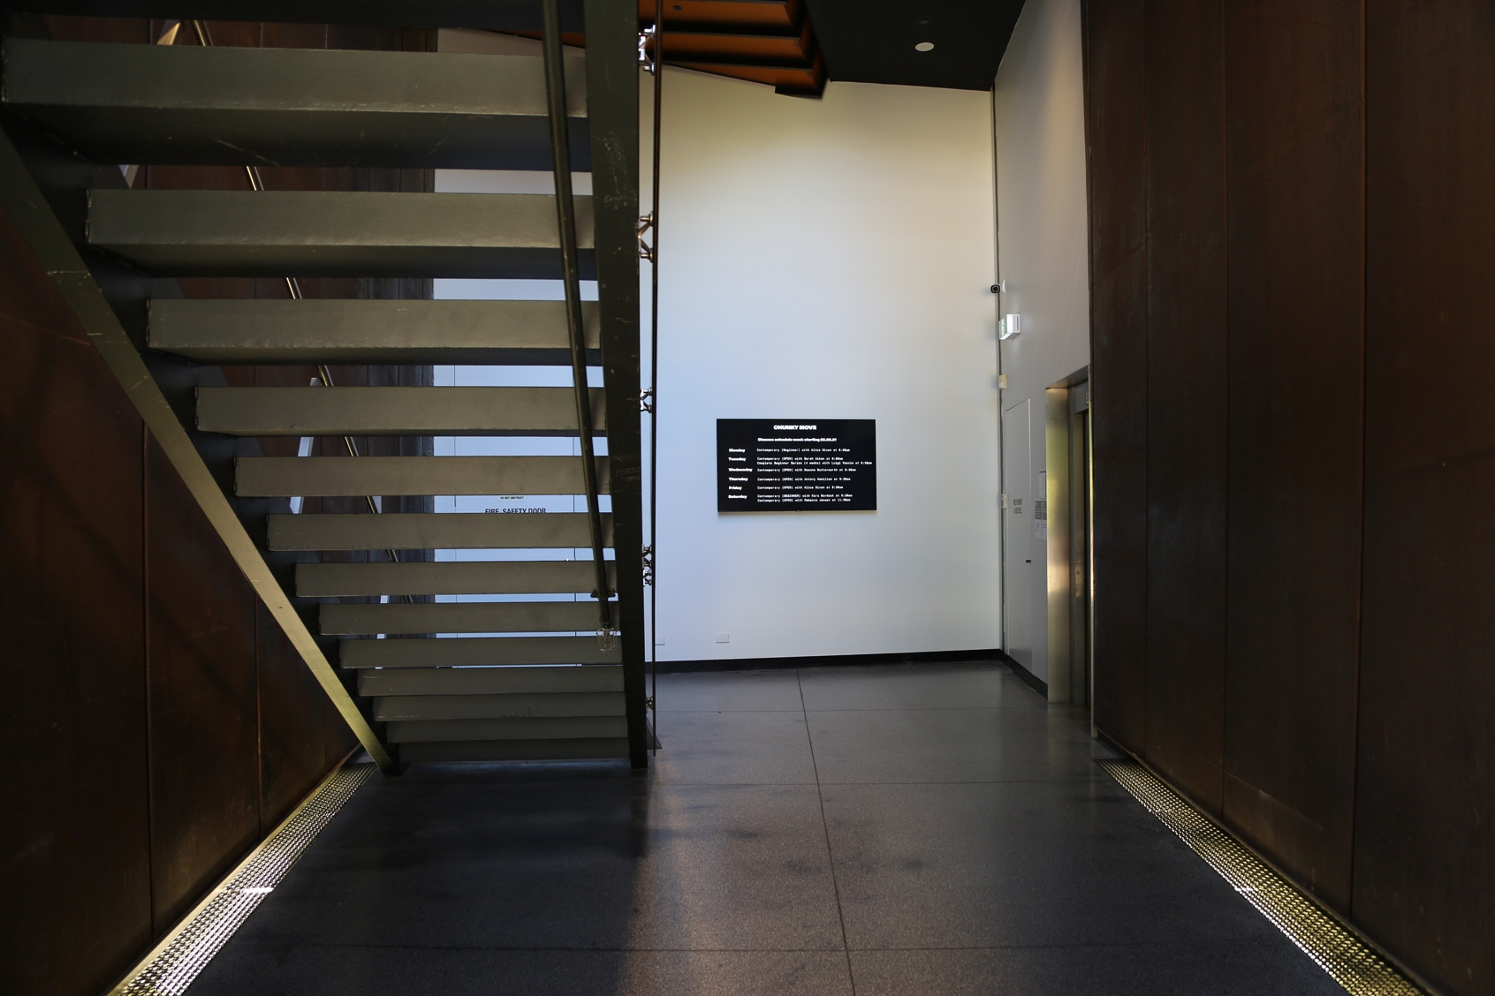

This is the lift:
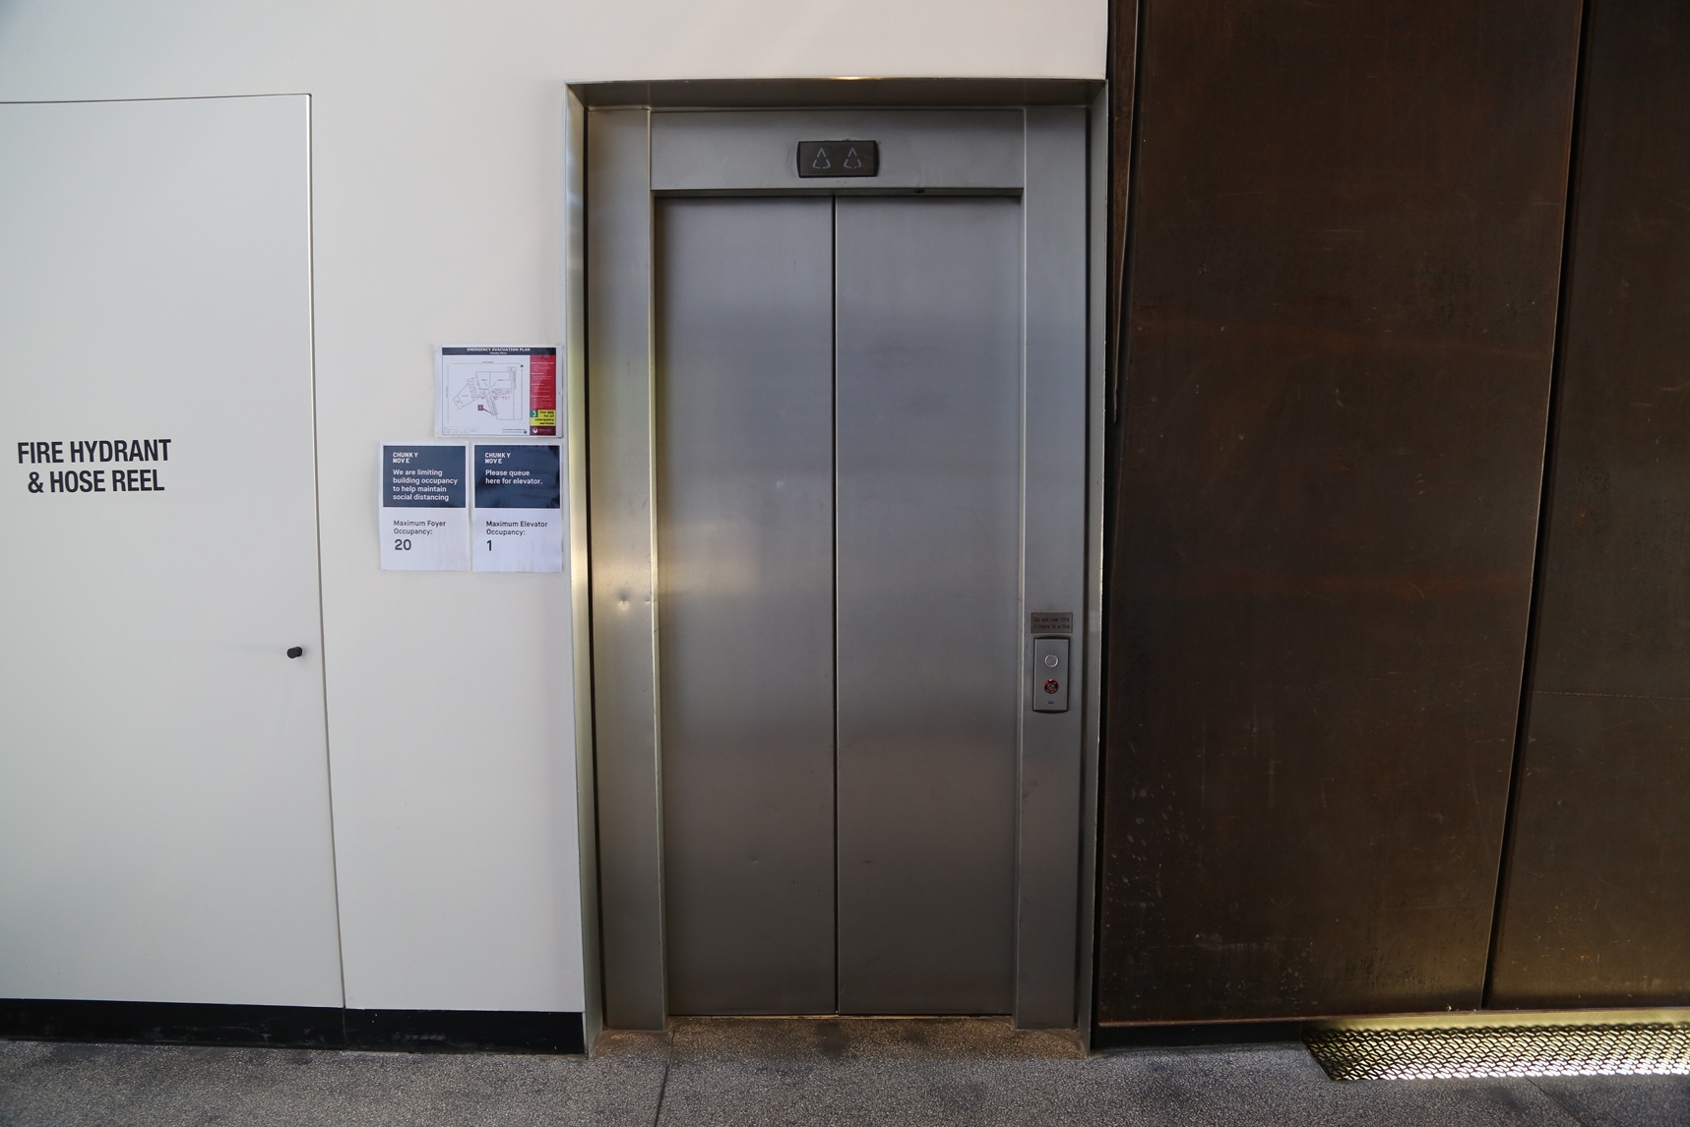

These are the stairs:
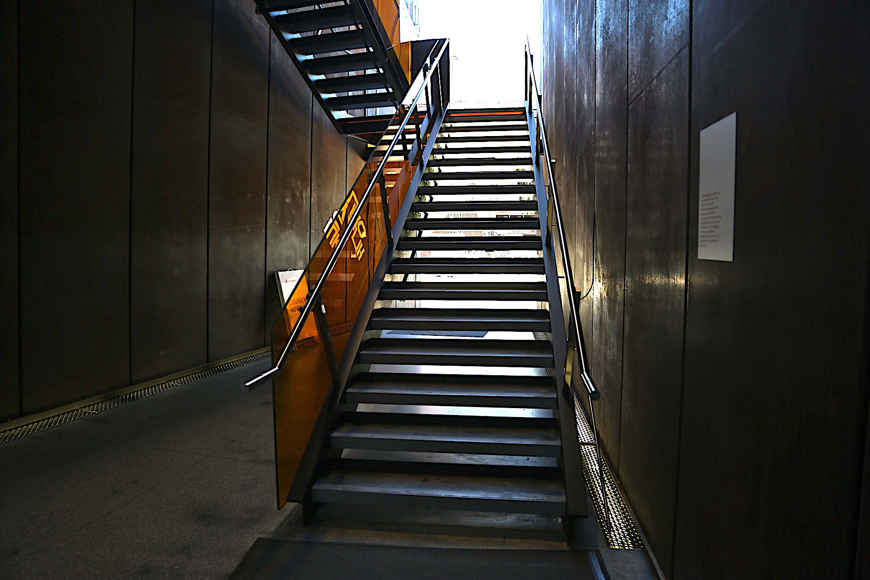

On level 1 you will see a black desk. This is where a friendly Chunky Move team member will be. They will help you with any information about Chunky Move and your visit. If you are meeting another member of the Chunky Move team, the person at the front desk will assist you.
This is the front desk:
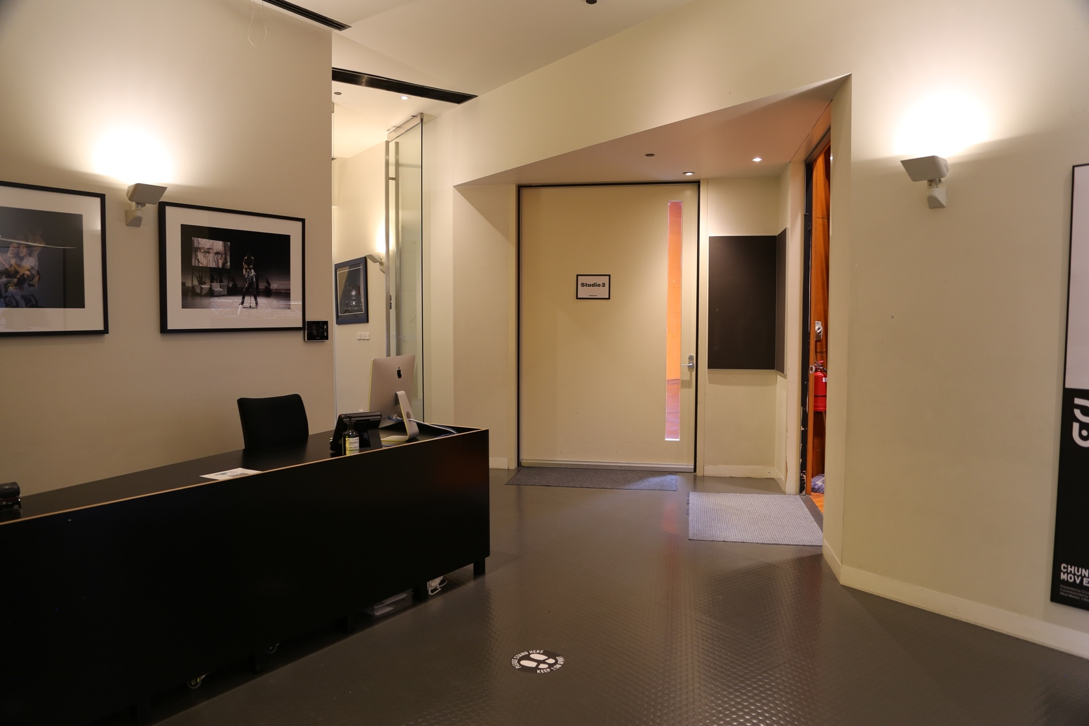
There are two studios in our building. They are side by side next to the front desk.
This is the front door of Studio 1:
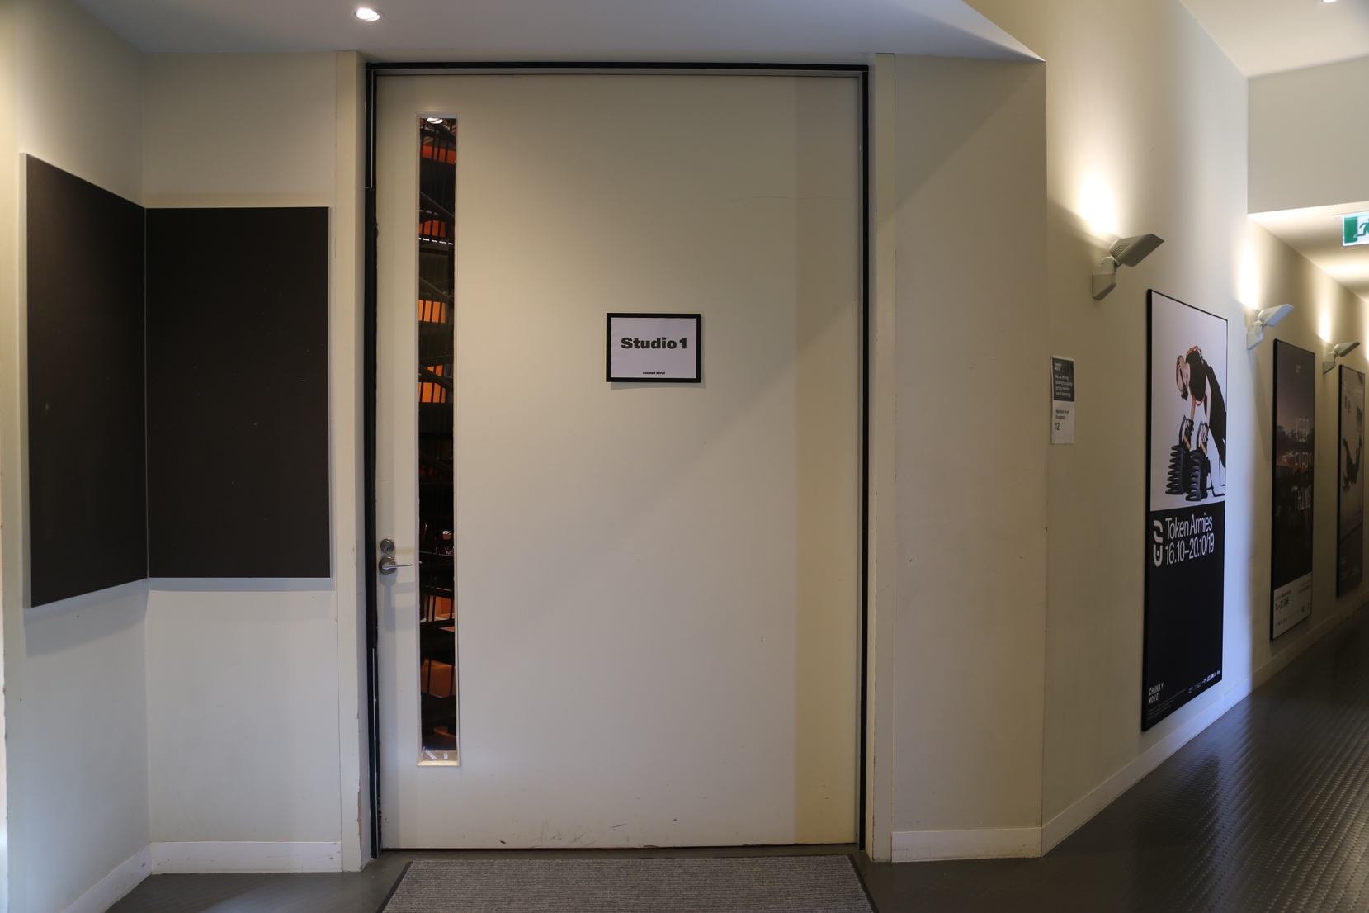

This is the front door of Studio 2:
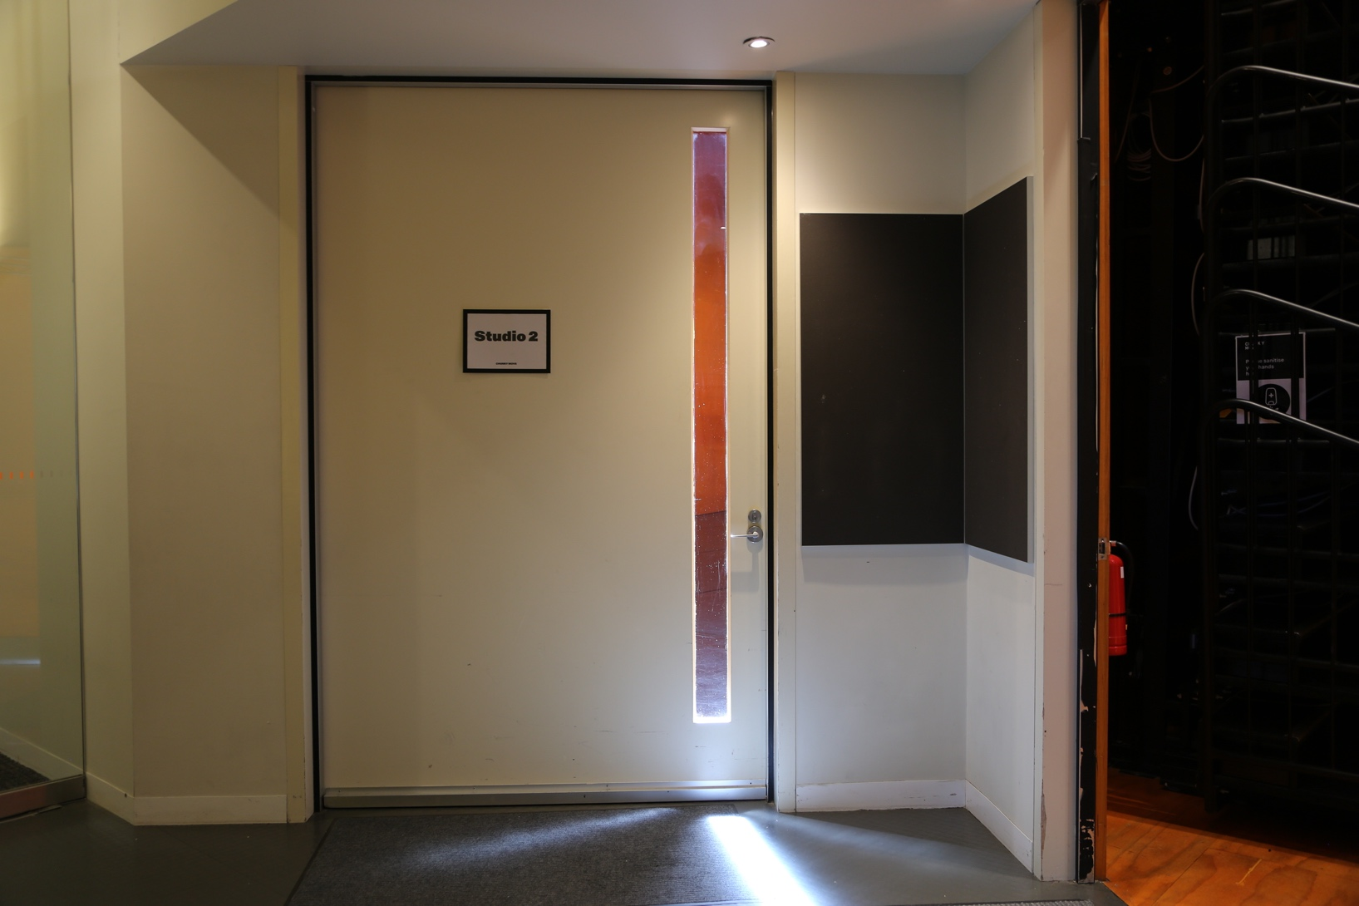

If you are unsure of which studio you are visiting at Chunky Move, a team member will be there to assist you.
Studio 1 is our larger studio. It has a seating bank which is mostly packed up against the wall, however sometimes it will be set up in the space to accommodate audiences.
This is Studio 1:
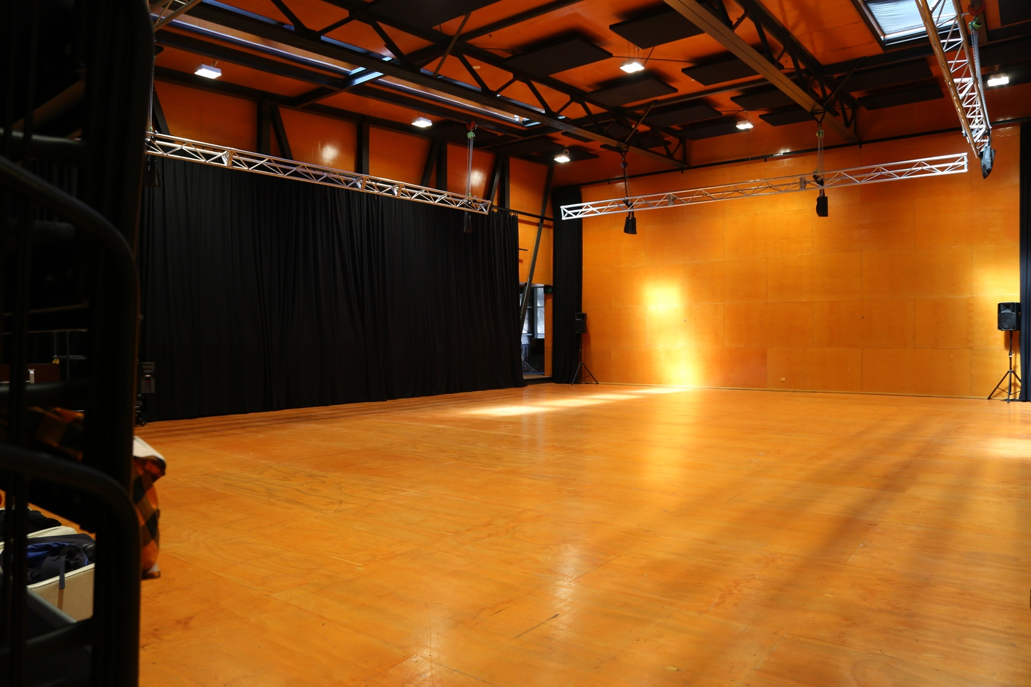
Studio 2 is our smaller studio.
This is Studio 2:
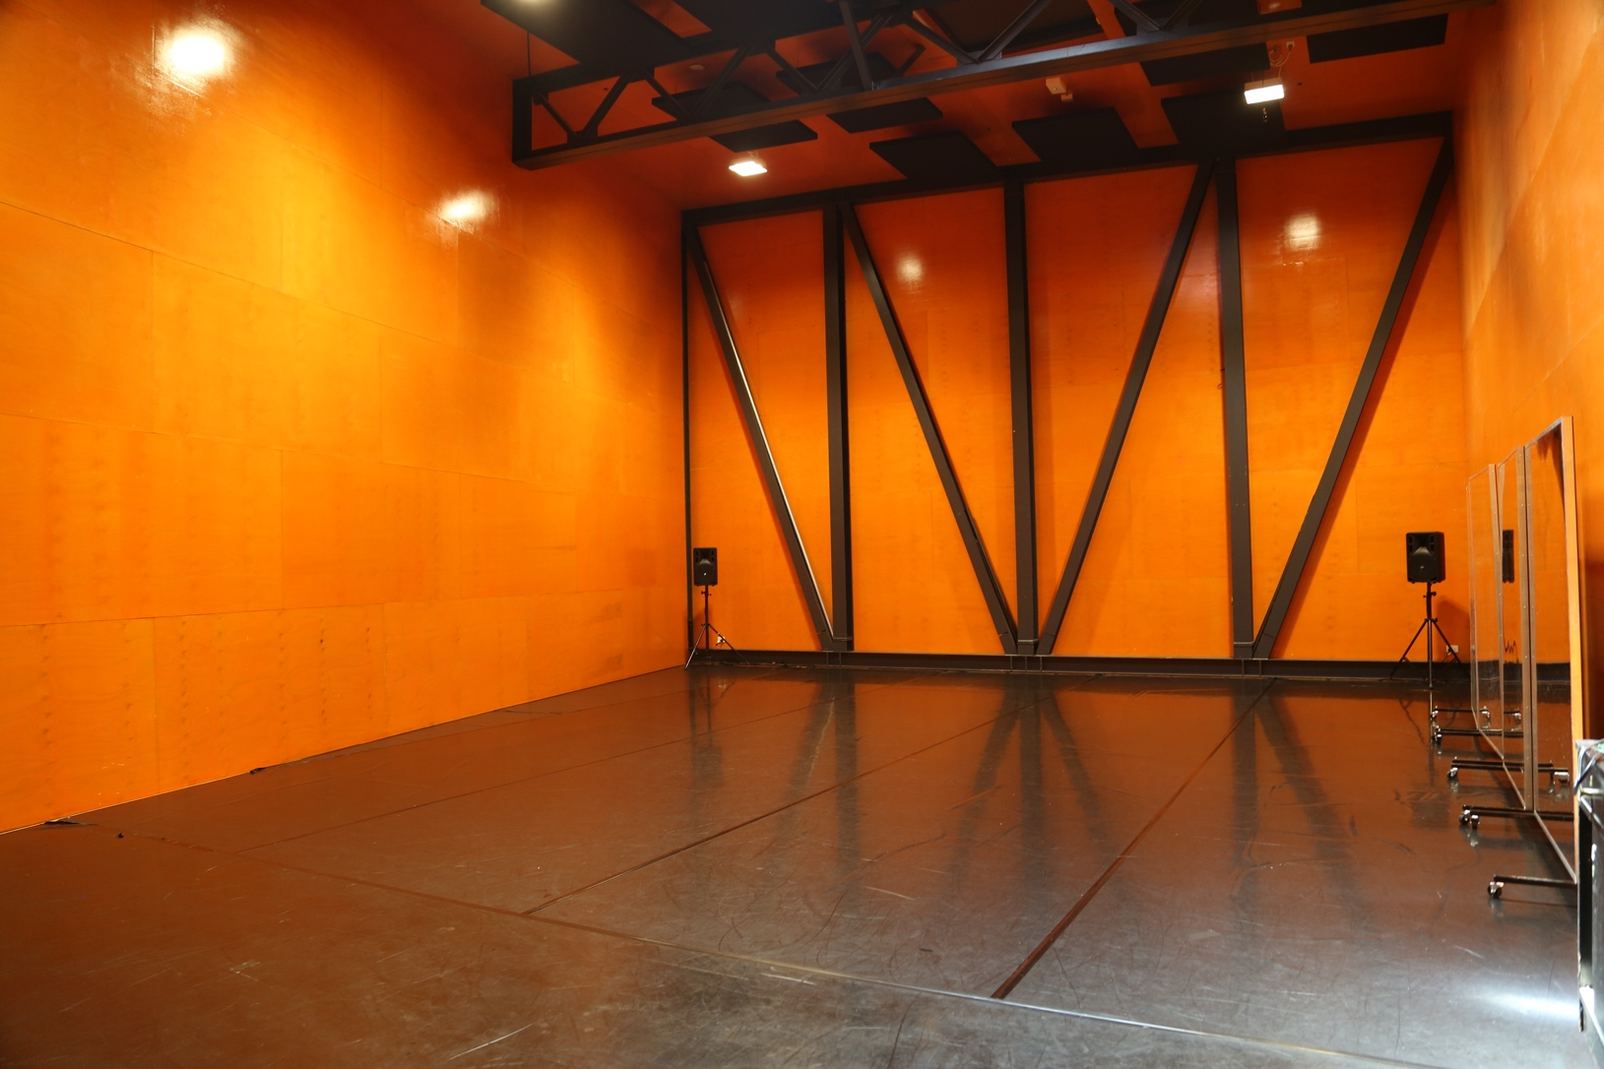

The kitchenette and bathrooms are located on this level in the corridor.
This is the corridor:
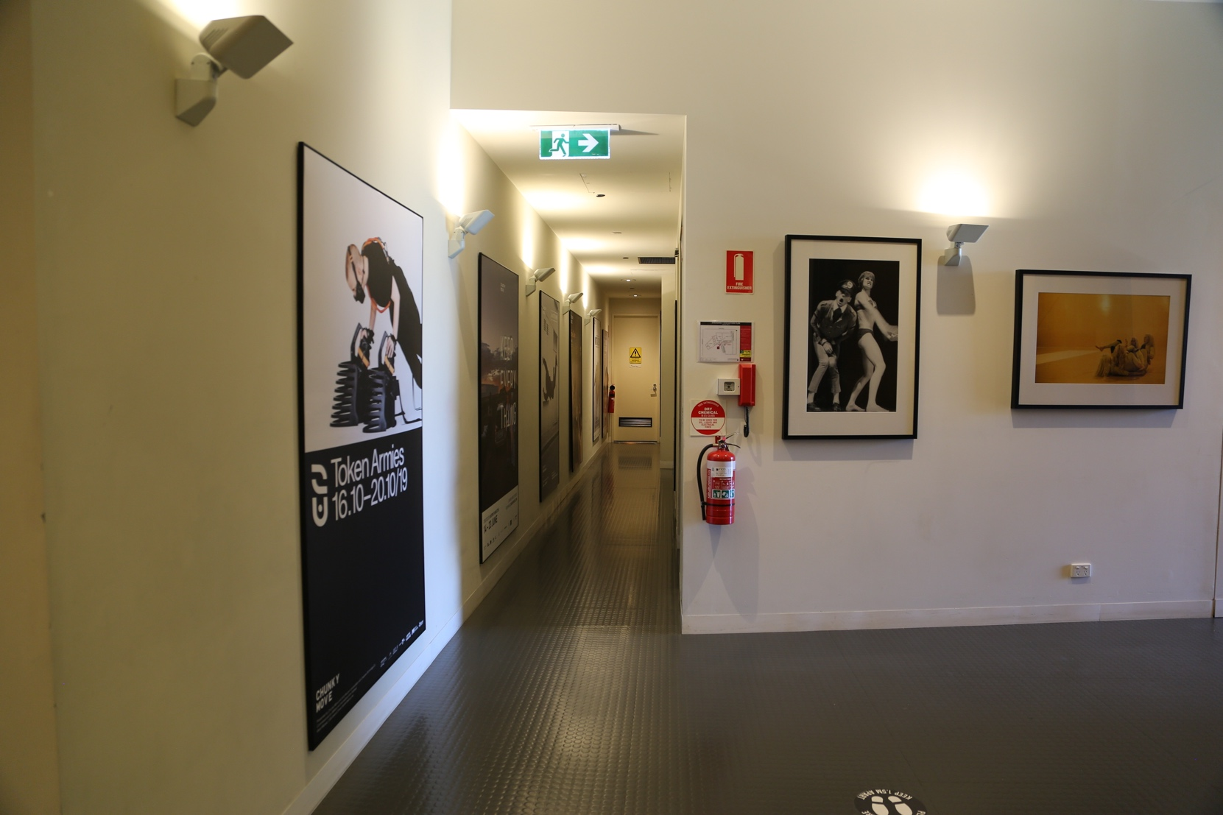

There is a kitchenette in the corridor on the right.
It has a tap which has filtered water, a kettle and a microwave. There are also cups, plates and cutlery. If you need assistance to find anything in the kitchenette, a Chunky Move team member will be able to assist you at the front desk.
This is the kitchenette:
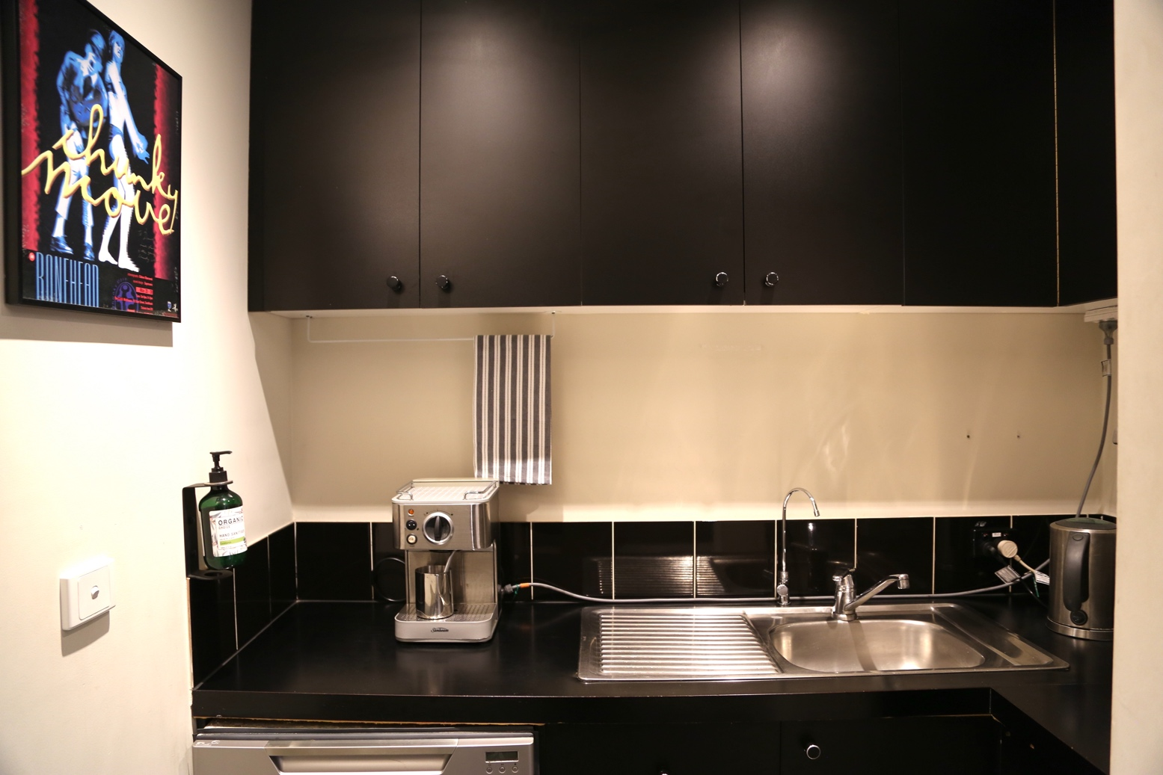

The bathrooms are just past the kitchenette in this corridor. The doors are also on the right. The bathrooms are clearly marked. There are toilets and showers in all the bathrooms.
These are the front doors to the three bathrooms:
Female Toilet & Change Room:
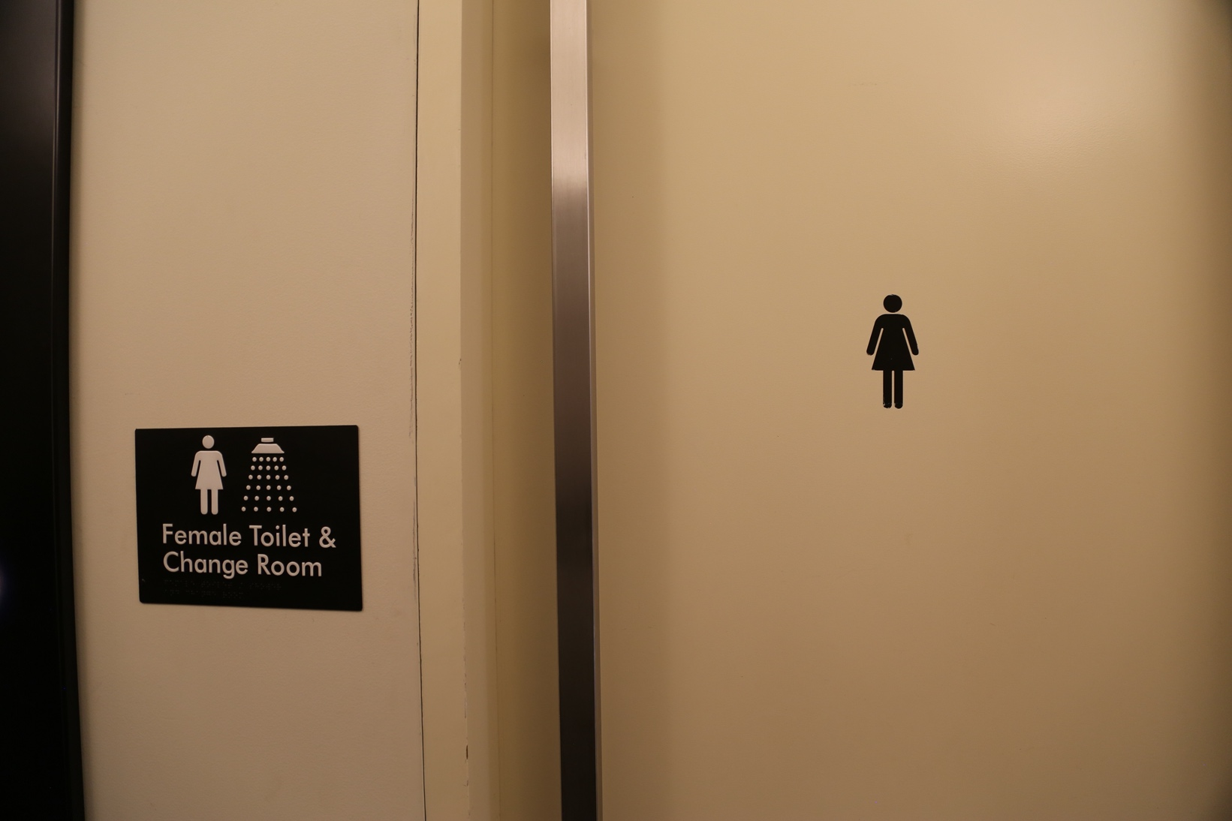
All Gender Toilet RH and Shower:
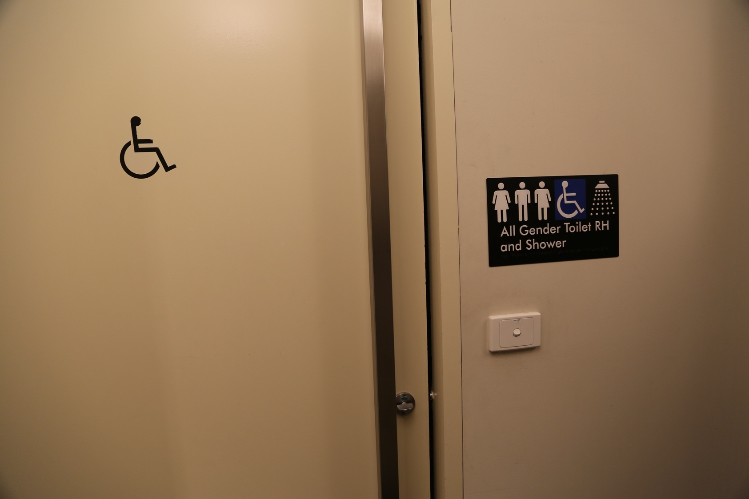

Male Toilet & Change Room:
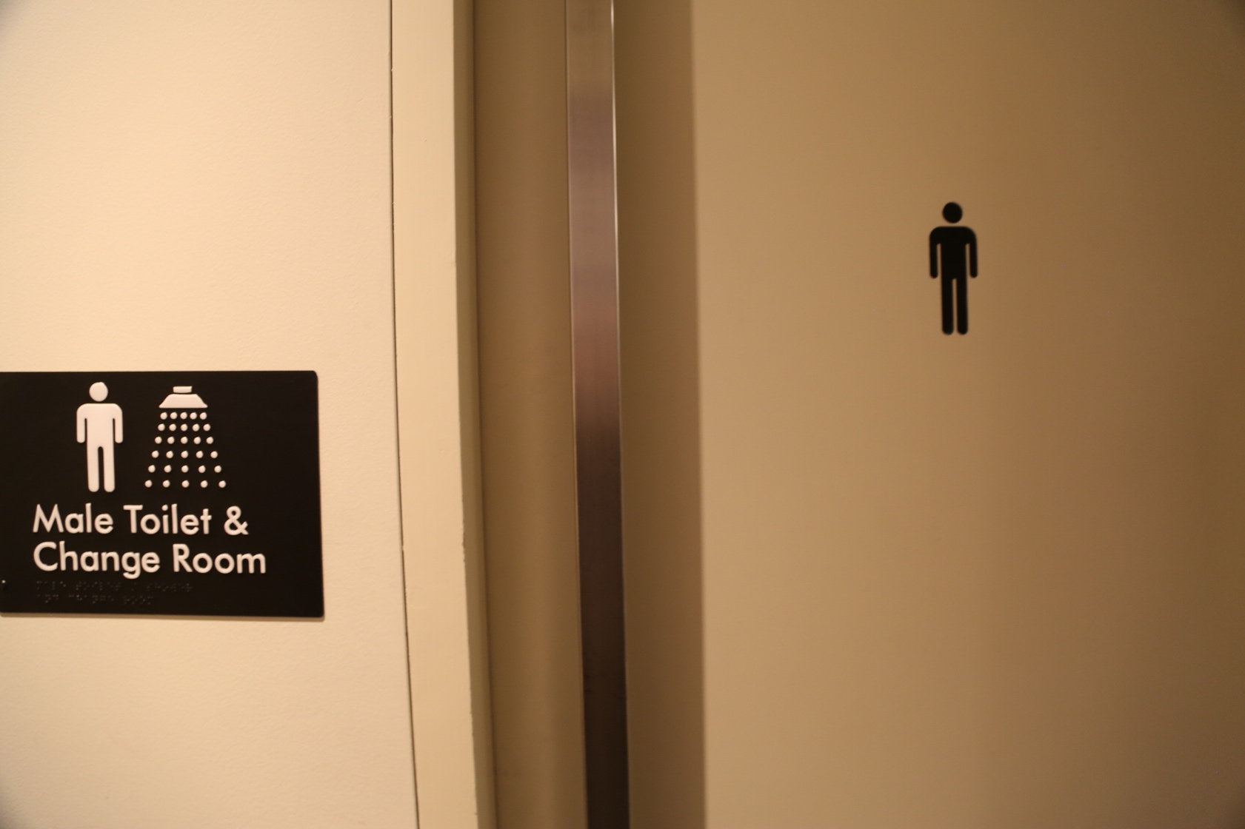

EXIT:
When you have completed your visit to Chunky Move you will leave by the stairs or lift. This is the same way that you entered the building. You can ask a Chunky Move team member to assist you. They will be at the front desk.
When you see the glass front door on the ground level, there is a button on the right. Push this button and the door will open. The door will open away from you.
This is the button to exit our building:
